Pokhara University

Level: Bachelor | Semester – Fall | Year : 2011
Programme: BE |  | Full Marks: 100
Course: Electronic Circuits I |  | Pass Marks: 45
 |  | Time : 3hrs.

Candidates are required to give their answers in their own words as far as practicable.
The figures in the margin indicate full marks.

Attempt all the questions.

 | - Prove that the current gain of common base amplifier circuit is always less than 1.  - Find A_{VS} and V_{L} in the circuit shown below: (Take: β=100)  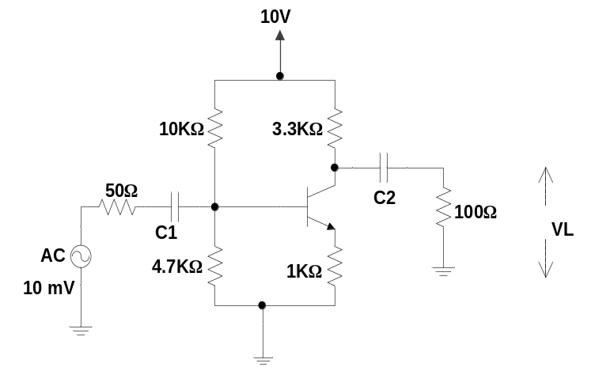 | 7  8
 | - What is frequency response? Obtain high frequency response of Common emitter amplifier circuit?  - What are the advantages of RC coupled amplifier? For an RC coupled amplifier circuit of your own, obtain its overall gain? | 2+5  2+6
 | - Derive the efficiency of a class B amplifier. Draw the circuit of transformer coupled push pull amplifier.  - What are the advantages of negative feedback? Show that the noise can be reduced by using negative feedback circuits. | 5+2  2+6
 | - What is a sinusoidal Oscillator? Obtain the expression of frequency for crystal oscillator circuit.  - In the circuit shown below find R and Rf if the frequency of oscillation is 60 HZ.  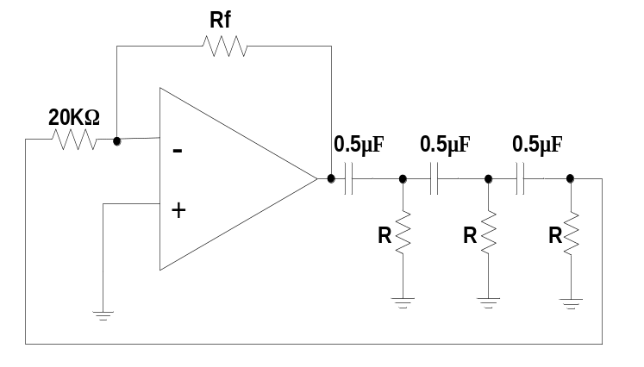 | 2+6  7
 | - What do you mean by differential amplifier? Design an operational amplifier circuit that produces an output equal to (0.1v – 0.33v₂).  - What is slew rate? Explain about astable multivibrator. | 7  2+6
 | - Describe R-2R ladder DAC and obtain the expression of its output voltage.  - What do you mean by rectifier? Explain full wave rectifier. | 8  7
 | Write short notes on any two:  - Regulated and unregulated power supplies  - Darlington-pair amplifier  - Schmitt trigger | 2×5

